JOUR 4251 Exam review (exam 1)
Today
● What exam 1 covers
● Important readings/topics (= study guide) ● Exam procedure
● Test format
● Your questions
What Exam 1 covers
Course readings from Fennis & Stroebe
● Chapter 1 - Introduction
● Chapter 2 - Attention
● Chapter 3 - Memory
● Chapter 4 - Attitude
Lecture notes (!)
What’s important in course readings?
Readings have three components:
● Key learning point(s)
● Examples to illustrate those learning points (e.g., studies / experiments) ● Useful but background detail
What is more important?
Tip1: Start by reading summary (at the end of each chapter) Tip 2: Check out glossary at the end of the book
Chapter 1
● Unique selling point
● Functions of advertising (informing vs. persuading)
● Hard-sell versus soft-sell approach
● Alpha vs. omega strategy
● What is an experiment
○ Random assignment, stimulus, dependent/independent variable, correlation, causation
● Direct vs. indirect source
● Message sidedness (two-sided messages)
Chapter 1
● Sales response model
○ Concave
○ S-shape
● Behavioral approaches
○ Hierarchy of effects model (AIDA) ■ Foote, Cone, and Belding Grid ○ Cognitive response approach ○ Dual process theories
● Ego-depletion
Chapter 2
● Preattentive analysis
○ Matching activation hypothesis
○ Hedonic fluency (conceptual + perceptual fluency) ● Focal attention
○ Motivation, Salience, Vividness, Novelty
○ Pioneering advantage
○ Assimilation/contrast
Chapter 2
● Comprehension
○ Juxtaposition
○ Omit comparisons
○ Pragmatic inferences
○ Affirmation of the consequent ○ Truth effect / sleeper effect ● Elaboration
○ Self schema
○ Meta-cognition
Chapter 3
● Memory
○ Encoding, storage, retrieval, forgetting ● Multi-store model of memory
○ Sensory memory
○ Short-term (working memory)
○ Long-term memory
● Baddeley & Hitch Model of working memory ○ Central executive
○ Phonological loop
○ Visuospatial sketchpad
○ Episodic buffer
Chapter 3
● Long-term memory
○ Explicit memory (episodic vs. semantic)
○ Implicit memory
○ Priming (supraliminal vs. subliminal)
○ Knowledge structures (categories, scripts, networks) ● Forgetting the message
Chapter 4
● What are attitudes?
○ Evaluative response, directed to an attitude object, derived from 3 classes of information
● Self-perception theory
● Explicit vs. implicit attitudes
○ And how to measure them (not detailed, overall idea)
● Why do people hold attitudes?
○ Adjustment function
○ Value-expressive function
○ Ego-defensive function
○ Knowledge function
Chapter 4
● Attitude strength
○ Accessibility, Importance, Knowledge, Certainty ○ Ambivalence
● Attitude formation
○ Heuristics
○ Mere exposure
○ Classical and evaluative conditioning
○ Behavior (self-perception theory & reinforcement) ● Purchasing goals
○ Utilitarian, self-expression, identity, hedonic
Lecture slides
Serve to help you make sense of readings
Might give you an idea what key concepts / learnings are
If I talked about something in class (especially more than once), chances are I think it’s important. So, spend some quality time with lecture notes…
USE “RECAP” SLIDE FOR IMPORTANT CONCEPTS!
Exam procedure
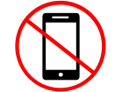
Make sure you bring your laptop (unless you already told us you need one), make sure it is charged, and has lockdown browser installed!
You will have the entire 75 minute exam period, so no need to panic if you encounter technical difficulties
You can leave after the first 25 minutes or when you are finished with the exam. Take an aisle seat if you know of yourself you are quick to make leaving less disruptive.
Done? Sign + date.
Two locations (same time)
Murphy 130 (Here)
● Clouse - Wilowske (unless you need a laptop)
Appleby Hall 227
● Students who requested a laptop
● Adamle - Chinander

Appleby Hall 227
Computer room
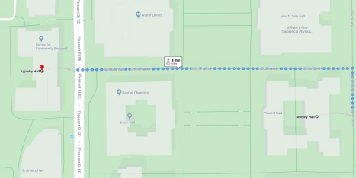
Exam procedure
Non-native speakers
A dictionary is allowed.
Not acceptable: device with accessible hard drive, Internet dictionary, notes in dictionary, etc.
NOTE: LockDown Browser does not allow you to open anything else Everyone
Exam is an individual test
Absolutely no Internet, Word, PowerPoint or other files.
No notes in any shape or form.
Only exam should appear on your screen.
We will use a LockDown Browser
Exam format
200 points in total
1. Multiple choice questions (23) 2. Matching questions (9 matches) 3. Short answer questions (2 out of 3) 4. Bonus questions (2)
Test format: multiple choice questions
The menti questions are a good example of what you can expect Advice:
Read question first, try to answer yourself before looking at the response options, then read ALL response options.
Do not “overthink”: Only one response option is true for each question. 5 points per question
Test format: matching questions
Match the term to its description (some items will not be used)
A. Motivation
B. Salience
C. Vividness
D. Novelty
……… When you are interested to buy sunglasses, you will notice ads of sunglasses more.
……… Helps to attract attention by it being presented in a new form.
Test format: short-answer questions
Precision is key.
We think with you, but the more you take us by the hand (i.e., precisely define concepts and clearly explain your answer), the more likely it is that we recognize that you are on top of things.
Don’t write a book; we expect you to think carefully about what an answer should address
Broader than MC => they test comprehension and application
Test format: short-answer questions
You get 3 questions but only need to answer 2! Pick two… We will grade the first two if you answer all three! 20 points each
Topics for the short-answer:
● Foote, Cone & Belding Grid
● Four methods of attracting attention
● Multi-Store Model of Memory
● Baddeley & Hitch Model of Working Memory ● Four purchasing goals
Might also ask you to fill in the model!
Practice quiz!
We made the menti questions used in class available to you to practice for the exam
Optional (not required)
Unlimited attempts
Immediately see correct answer
NOT GRADED
Available now until exam date
On Canvas (go to Quizzes)
Note. Just practicing these questions is NOT enough to pass the exam with a good grade. You need to study.
Your questions
Sales response models
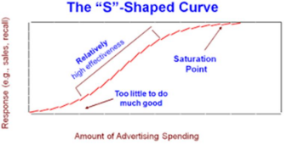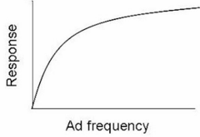Concave S-shape
Use of aggregated data
Hierarchy of effects models
● You don’t need to know all the models You do need to know/understand:
● AIDA (first model)
○ Attention, Interest, Desire, Action ● The idea behind these models ● Criticism on these models
Alpha vs. Omega strategies
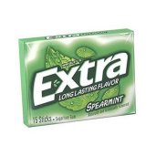
Direct vs. indirect source

Direct source
Spokesperson delivers the message (speaking or
demonstrating use of product)
Indirect source
Associated with the product, but not delivering the message (not speaking/demonstrating).
Example: logo of brand

Attention
1. Motivations
2. Salience
3. Vividness
4. Novelty
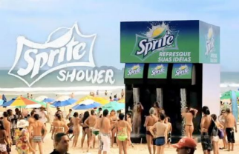
Strategies to muddy comprehension
Omit comparisons: “Dentists recommend Trident” => Over what? Eating chocolate bars?
Pragmatic inferences: “Brand X may be the best beer in the world” => well yeah, and Brand X may also be the worst. It isn’t false, but it isn’t maybe true.
Juxtaposition: “Be cool, buy brand X” => suggest a causal relationship (A=B)
Affirmation of the consequent: “if you can see it, you can make it: Brand X” => reverse cause and effect (B => A instead of A => B)
Matching activation hypothesis

Assumption that when one brain
hemisphere is processing focal
information, the other is activated and can process non-focal information.
Representativeness heuristic
Extent to which two stimuli are deemed to belong to the same overall category based on shared characteristics
Fluency
Subjective ease of processing Preattentive analysis
Perceptual vs. conceptual fluency
Memory models Baddeley and Hitch Model
Explicit memory
Semantic memory Episodic memory
Attitude functions
Attitudes will help consumers to separate good from bad. Decide whether to approach or avoid something.
Different functions can drive attitudes. Understanding the purpose of a consumer’s attitude is an imperative step toward changing an attitude.
Adjustment function
Value-expressive function
Ego-defensive function
Knowledge function
Priming
The process of making something more accessible in the mind “Top-of-mind”
Example: you just bought Brand X, it seems that a lot of people have brand X
Supraliminal vs Subliminal
Supra = above
Sub = under
Liminal = threshold
Other concepts questions
● Do we need to know procedure + names of IAT+AMP or just purpose + usability?
● Self-schema
● Metacognition
● Assimilation and contrast
● Difference implicit vs. explicit
● Can you correct for implicit attitudes? (prejudice)
Thursday
● Start at 2:30 pm
○ Murphy 130: Clouse - Wilowske (unless you need a laptop) ○ Appleby Hall 227: Adamle - Chinander + students who requested a laptop
● Bring laptop (charged) + lockdown browser + wifi access Next week (Tuesday):
● Tuesday: Read Segijn et al. 2017 on multitasking before coming to class ● Thursday:
○ Assignment #3
○ Reading response #5

